|  |  |
| --- | --- |
| **Name:** | DIPTI SHARNAGAT |
| **Roll No & Branch:** | CSE-55 |
| **Class/Sem:** | BE/VII |
| **Experiment No.:** | 05 |
| **Title:** | Develop a scene in Unity that includes a sphere and plane . Apply Rigid body component, material and Box collider to the game Objects.Write a C# program to grab and throw the sphere using vr controller |
| **Date of Performance:** |  |
| **Date of Submission:** |  |
| **Marks:** |  |
| **Sign of Faculty:** |  |

**Aim:** Develop a scene in Unity that includes a sphere and plane . Apply Rigid body component, material and Box collider to the game Objects.

**Theory:** Virtual Reality (VR) is a cutting-edge technology that immerses users in digital environments, making them feel as if they are physically present in those spaces. Within Unity, a popular game development platform, it is entirely feasible to apply essential components to game objects, such as the Rigid body for simulating physical behaviours, Box Colliders for defining collision shapes, and Materials for controlling the objects' visual properties. Moreover, in Unity, developers can craft a dynamic VR experience that enables users to pick up and throw a sphere with a VR controller. This is accomplished by incorporating a VR software development kit (SDK), configuring a VR camera rig to replicate the user's perspective, and implementing custom scripts to facilitate the interaction. The XRGrabInteractable script, often used for this purpose, tracks the controller's input and applies forces to the Rigid body component of the sphere, allowing users to manipulate and launch it within the VR environment, fostering an engaging and immersive VR interaction.

**Procedure:**

1. Create a new Unity 3D project.
2. Import VR SDK for your hardware.
3. Import assets (sphere, plane, materials).
4. Create sphere and plane objects.
5. Add Rigid body components to both.
6. Apply materials to objects.
7. Add Box Collider to the sphere.
8. Implement VR controller interaction using provided SDK components.
9. Write a script for picking up and throwing the sphere.
10. Attach the script to the VR controller object.
11. Test the scene in your VR environment.

**Result:**

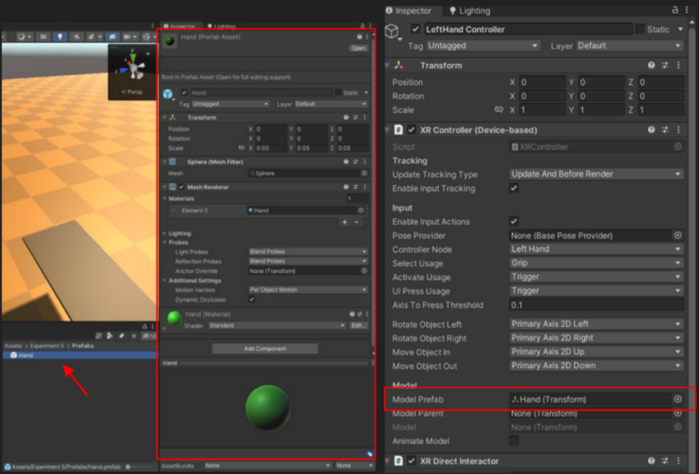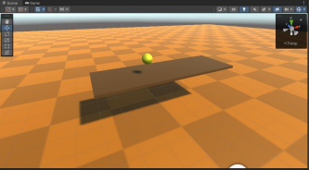

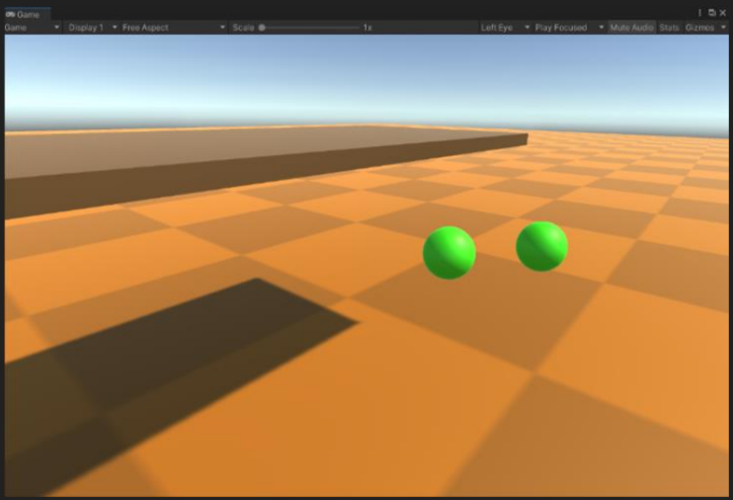**Conclusion:**

**Conclusion:**

Developing a Unity scene with a sphere and plane, applying the Rigid Body component and Box Collider, and customizing materials enhances the physics and visual aspects of the objects. This project highlights how Unity empowers developers to create interactive and realistic 3D environments, making it a valuable tool for game development, simulations, and various interactive applications.